Rest Oauth 1.0 Step

Objective

A RESTAPI defines a set of functions which developers can perform requests and receive responses via HTTP protocol such as GET and POST etc.

In Rest OAuth 1.0 step a rest call by using authorization type OAuth 1.0.

UI

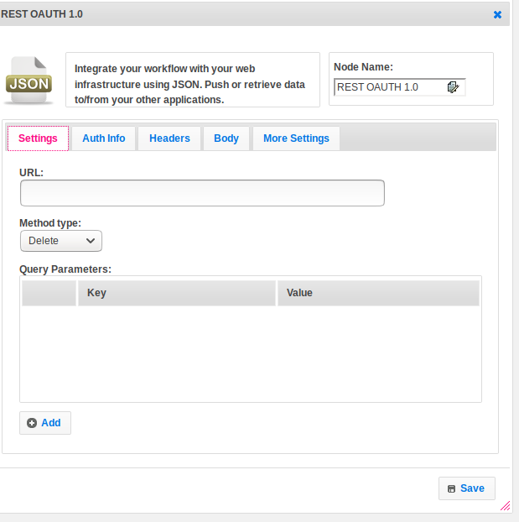

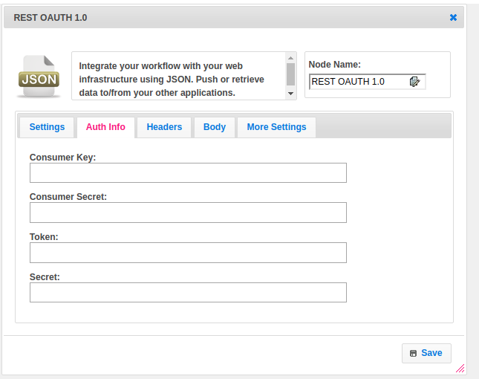

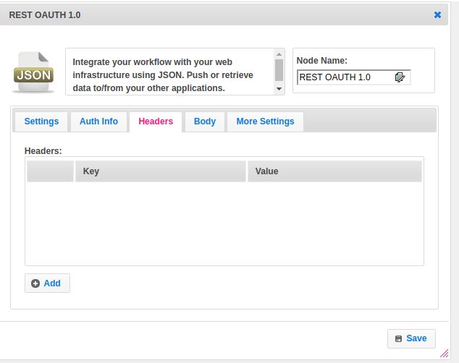

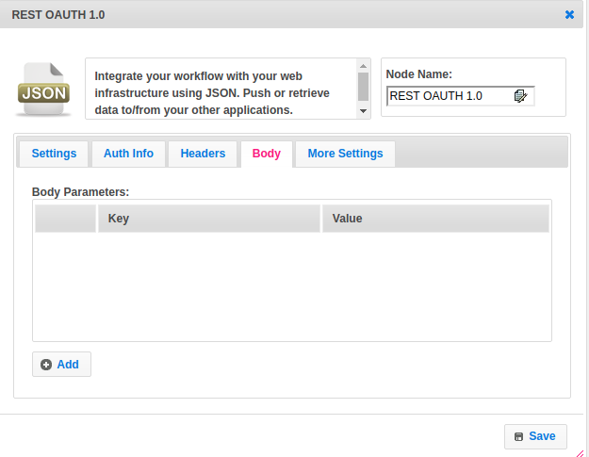

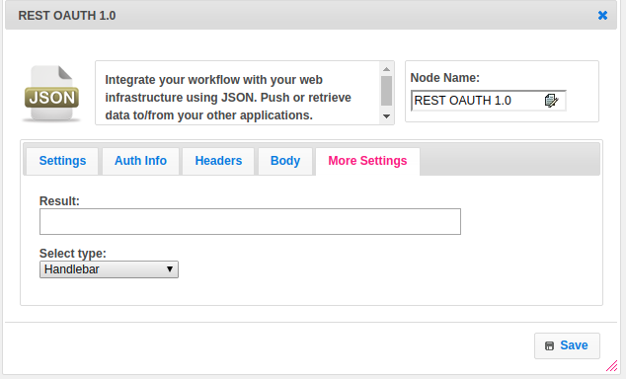

## Attributes

|  |  |
| --- | --- |
| **Attributes** | **Description** |
| **1. URL** | The URL is an essential part of a REST API. |
| **2. Method Type** | Following four HTTP methods are commonly used in REST-based architecture.  GET − Provides read-only access to a resource.  POST − Used to create a new resource.  DELETE − Used to remove a resource.  PUT − Used to update an existing resource or create a new resource. |
| **3. Query Parameters** | The query parameter or query string is the part of a [uniform resource locator](https://en.wikipedia.org/wiki/Uniform_resource_locator) (URL) which assigns values to specified parameters. The query string commonly includes fields added to a base URL.  Provide the parameters in the form of a key-value pair. |
| **4. Consumer Key** | Consumer key is essentially the API key associated with the application (Twitter, Facebook, etc.). This key (or 'client ID', as Facebook calls it) is what identifies the client. By the way, a client is a website/service that is trying to access an end user's resources. |
| **5. Consumer Key** | Consumer secret is the client password that is used to authenticate with the authentication server, which is a Twitter/Facebook/etc. the server that authenticates the client. |
| **6. Token** | An access token is what is issued to the client once the client successfully authenticates itself (using the consumer key & secret). This access token defines the privileges of the client (what data the client can and cannot access). |
| **7. Secret** | every time the client wants to access the end user's data, the access token secret is sent with the access token like a password (similar to the consumer secret). |
| **8. Headers** | Parameters included in the request header, usually related to authorization.  Provide the parameters in the form of a key-value pair. |
| **9. Body Parameters** | Parameters included in the request body.  Provide the parameters in the form of a key-value pair. |
| **10. Result** | Used to store the response of the request. |
| **11. Select Template** | Select Template is used to set the value type.  Value types are two types.  1.hb-HandleBarss  2.ftl-Freemarker Template Language. |

## Executor Description

Build a URL. For GET, HEAD and OPTIONS requests, parameters will be added to the query string in the requested URL. Add Headers given in the step. Add Post Data. Just set the data which has been given by the user, this data is expected to be JSON data. Set the method.If OAuth 1.0a Authentication, sign the request. Pass Consumer Key and Consumer Secret to API end URL, get token as a response. Call setTokenWithSecret method by passing token and secret. Make a request Get Response. Check and assign the response content type. Add response in a string when the content type is JSON / plain text else read bytes and assign.

## Resource

Please refer the below link to get more details.

<https://dzone.com/articles/busy-developers-guide-restful>